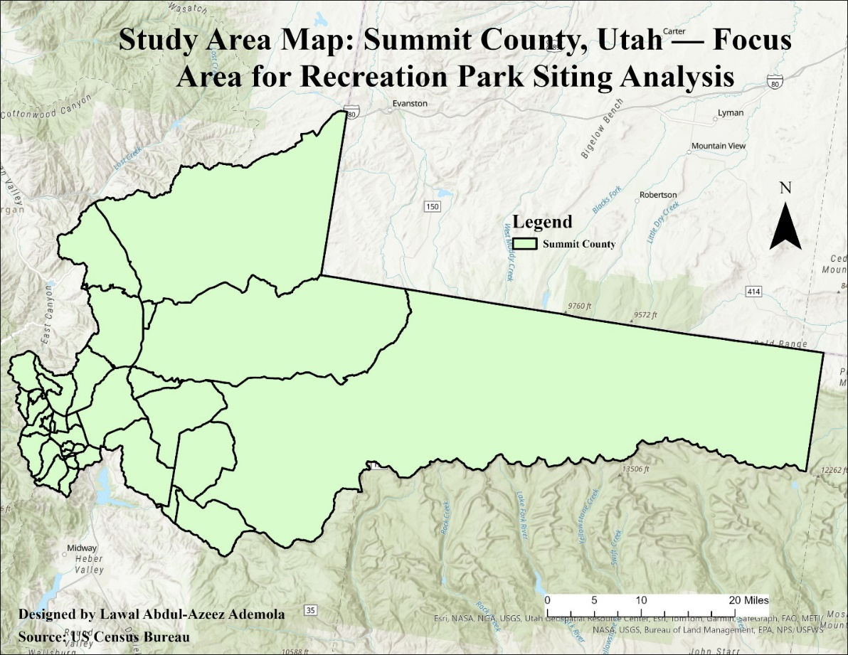

Figure : Map of the study area

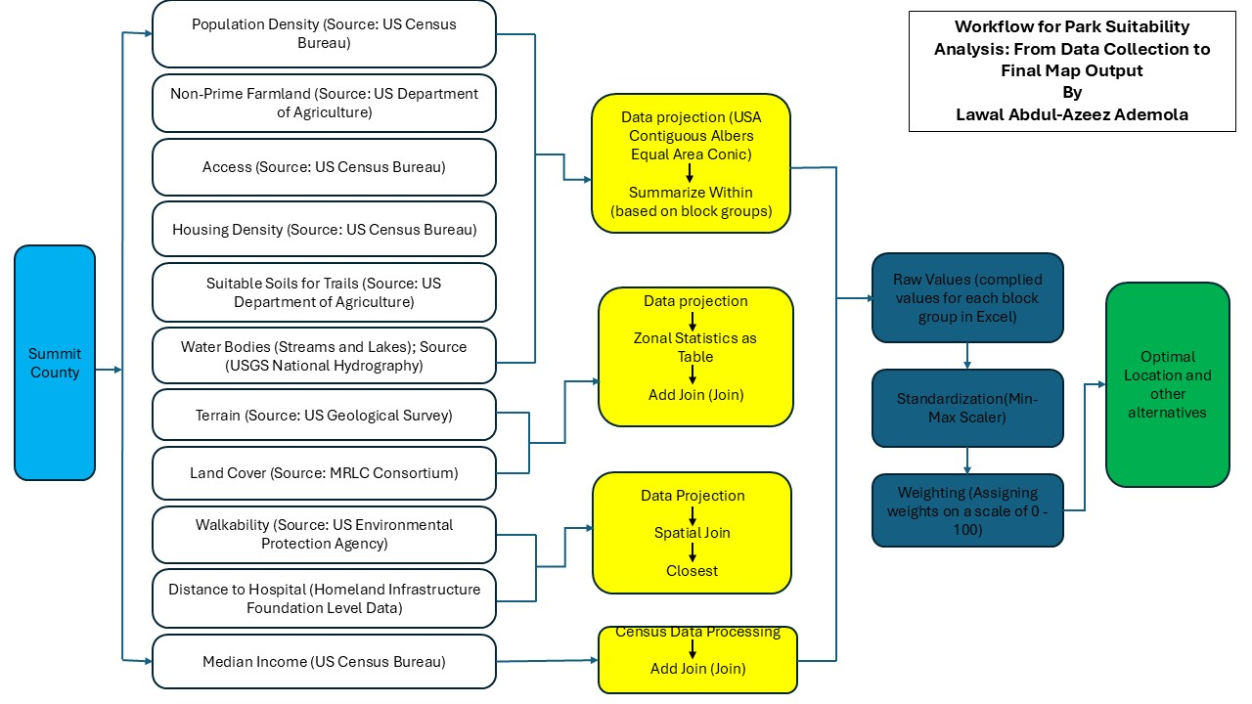

Figure : Workflow plan for the suitability analysis

Figure : Distribution of suitable land cover for park development

Figure : Distribution of water bodies in the Summit County

Figure : The density of road networks in the Summit County

Figure : The density of housing units in the Summit County

Figure Distribution of terrain in the Summit County

Figure Distribution of the population density in the Summit County

Figure : Distribution of non-farmland coverage for sitting the proposed park

Figure : Distribution of soil suitable for sitting trails in Summit County

Figure : Distribution of Walkability index in the Summit County

Figure : Distance to federal health facility in the Summit County

Figure : Distribution of median income in the Summit County

Figure : Optimal locations for sitting the park in Summit County